Year 6 Summer Brainbuilder- Rivers
2 and 3 stars
In the Autumn term, we will be learning about Rivers. Over the holidays, we would like you research this topic at home. Every task should be completed to high standards. Handwriting should be cursive and written neatly on every page. Make sure you include colour and pictures.
Brainbuilder should be handed in on 4th September 2018.

Create a fact file about the longest river in the world.
Draw a map of where rivers are located around the world.

Create a fact file about the shortest river in the world.
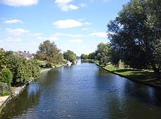
Complete the sheet- features of a river.
Create a 3D model of how rivers flow.
Create a glossary page of the river features.

Write down how many different ways rivers can be used.
Draw the water cycle. Make sure you include colour.

