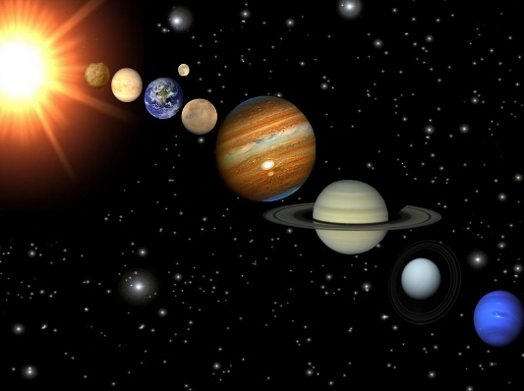
3 stars
1. Design an exciting topic page.
2. Find out the names of the 8 planets in our Solar System. Draw or make a model of the planets.
3. Choose one of the planets and make a fact file about it.
4. Find out why we have day and night. Can you use a diagram to explain what you have found out?
5. Choose a famous astronaut e.g. Neil Armstrong, Tim Peake, Helen Sharman, or Uri Gagarin. Write a biography about them.
6. Design an alien of your own. Can you explain what its special features are for?
7. Imagine you were travelling into space to meet an alien. What 10 things would you take to show it what life on Earth is like? You can draw them or write about them in sentences.
8. Find out about the first moon landing. Can you write a newspaper report about it?
9. Make a glossary of the following topic words: axis, orbit, rotate, spherical.
